PROJECT REPORT
BUDGET BASIC
Personal Finance Education / Financial Literacy for Teenagers
TEAM TECH WIZARDS
PROJECT OVERVIEW
Project Name | Budget Basic
Team Name | Tech Wizards
Project Domain | Personal Finance Education / Financial Literacy for Teenagers
Platform Type | Responsive, client-side multi-page website
Technology Stack | HTML5, CSS3, Bootstrap 5, JavaScript, jQuery
Version | 1.0
TEAM MEMBERS
S. No. | Student Name | Student ID
1 | Abdul Samad | 1729914
2 | Muhamad Talha | 1731374
3 | Muhammad Yasin | 1731081
4 | Muhammad Shabir | 1731350
5 | Muhammad Haseeb | 1731377
Prepared by Team Tech Wizards

BUDGET BASIC
Project Report Document

1. Executive Summary & Problem Definition

1.1 Project Title & Overview
- Project Title: Budget Basic
- Project Domain / Category: Personal Finance Education / Financial Literacy for Teenagers
- Platform Type: Responsive, client-side multi-page website (no backend)
- Version: 1.0

1.2 Problem Statement
Most teenagers start handling money — allowance, pocket money or small earnings — without ever being taught how to plan it. They rarely track where each rupee goes, so by the end of the month they cannot explain their own spending and are often short before the next payday. Existing personal-finance apps are built for adults, assume salaries and bank accounts, and are too complex or intimidating for a teenager who simply wants to understand the difference between a need and a want and start saving something every month.

1.3 Proposed Solution
Budget Basic is a lightweight, browser-based educational website that teaches teenagers the fundamentals of budgeting through hands-on tools rather than long articles. Built with HTML, CSS, Bootstrap, JavaScript and jQuery with no backend or database, it applies the 50/30/20 rule (50% needs, 30% wants, 20% savings) throughout the site. Core features include a Budget Calculator, a Goal Planner, an Expense Planner, a Needs-vs-Wants gallery and quiz, a rule-based budgeting chatbot, and feedback/contact/about pages — giving teenagers a private, simple way to understand their money before a spending mistake costs them their savings.

2. System Architecture & Information Flow

2.1 Information Architecture & Sitemap
Every section is reachable from the sticky navigation bar on the Home page, and the rule-based chatbot floats as a global widget available on every page. The diagram below maps the site's structure.
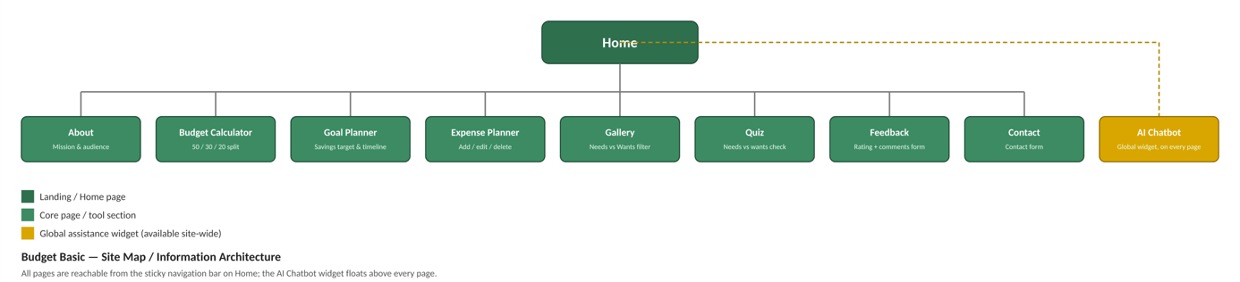
Figure 1 — Budget Basic site map / information architecture

2.2 Main Flow Chart
The flow chart below traces the user journey from the Home page through the Core Information Hub into each functional module, showing how the Expense Planner and navigation bar read and write to Browser LocalStorage, and how every module ultimately leads to the Feedback / Contact section.
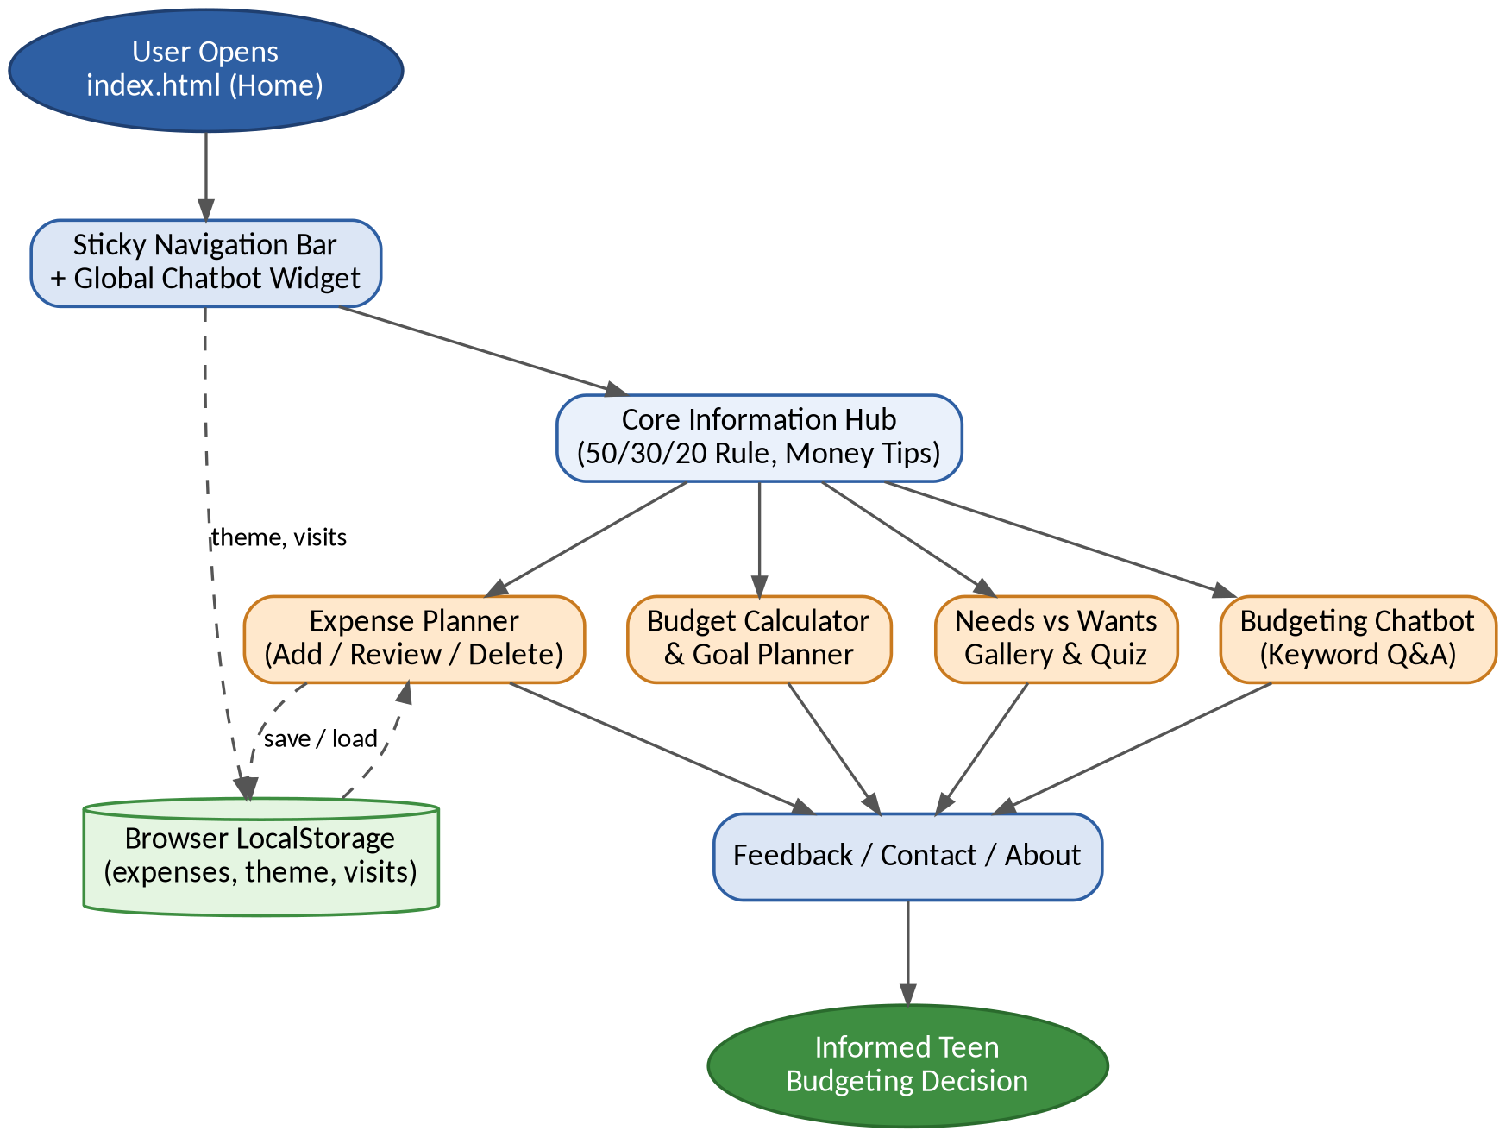
Figure 2 — Main user-journey flow chart

2.3 System Architecture & Data Flow Diagram
As a fully client-side application, all four layers below run inside the user's browser: the Presentation Layer (HTML5/CSS3/Bootstrap 5) captures interaction, the Application Logic Layer (JavaScript/jQuery) handles events, the Feature Modules perform the actual calculations, and the Persistence Layer (LocalStorage) stores data locally with no server ever involved.
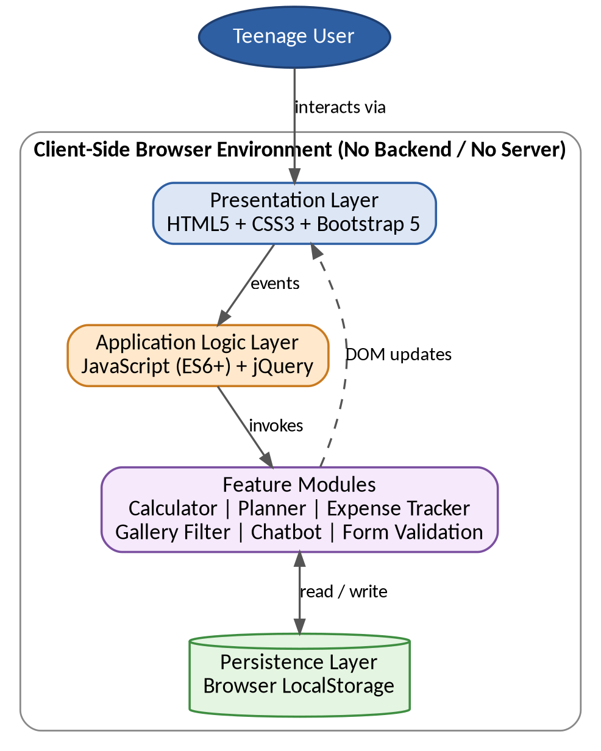
Figure 3 — Client-side system architecture & data flow

3. Functional & System Specifications

3.1 Functional Requirements Matrix
ID | Module Name | Functional Description | Implementation Approach
FR-01 | Landing & Navigation | Displays the hero banner, live clock/date widget, dark-mode toggle and a sticky global navigation bar linking every section of the site. | Client-side dynamic DOM updates (vanilla JS + Bootstrap navbar).
FR-02 | Core Information Hub | Presents the 50/30/20 budgeting rule, needs-vs-wants concepts and rotating money-tip guidance for teenagers. | Component-based dynamic rendering (JS arrays + DOM injection).
FR-03 | Budget Calculator & Goal Planner | Accepts monthly income, validates the field, and instantly splits it into Needs (50%), Wants (30%) and Savings (20%); the Goal Planner projects the months needed to reach a savings target. | Client-side arithmetic, input validation and real-time result rendering.
FR-04 | Expense Planner (Data Visualizer) | Lets the user add, review and delete day-to-day expense entries with date, category and amount, and keeps a running total. | Local array / LocalStorage handling with dynamic HTML-table generation.
FR-05 | Needs vs Wants Gallery & Filter | Allows multi-category filtering of example purchases so users can practise sorting items into needs and wants. | Dynamic array filtering and DOM show/hide updates.
FR-06 | Budgeting Chatbot (Assistance Helper) | Answers common questions on needs vs wants, saving, overspending and the 50/30/20 rule using pre-written guidance. | Keyword matching against a local question/answer dataset.
FR-07 | Feedback & Contact | Captures feedback (name, email, star rating, comments) and contact enquiries with strict client-side validation and an on-screen success confirmation. | Regular-expression validation and dynamic success/error messaging.

4. Hardware, Software & Development Requirements

4.1 Development & Operational Hardware
- Processor: Intel Core i5 or equivalent
- System Memory: 8 GB RAM minimum
- Display Output: Standard color screen, 1366×768 or higher
- Storage Space: Minimum 500 MB free disk space

4.2 Software Environment & Technical Tooling
- Development IDE: Visual Studio Code
- Frontend / Stack: HTML5, CSS3, JavaScript (ES6+), Bootstrap 5, jQuery
- Data Storage: Browser LocalStorage (expense entries, theme preference, visit counter) — no server-side database
- Design Tools: Figma / Canva for layout and graphic assets
- Development Assistance: AI coding assistants used for debugging and code-structuring support

5. Non-Functional Quality Attributes
Quality Attribute | Description
Performance | All calculations (budget split, goal timeline, expense totals) run instantly in the browser with no server round-trip, so results appear as the user types or submits a form.
Usability | Simple, teen-friendly language, large touch-friendly buttons, a persistent navigation bar and a rotating tips widget keep the learning curve low.
Responsiveness | Built with Bootstrap's grid and responsive utilities so pages adapt cleanly from desktop to tablet and mobile widths.
Security & Privacy | No backend, accounts or external data transfer — expense entries, theme choice and visit counts stay only in the user's own browser (LocalStorage).
Compatibility | Tested on the latest Chrome, Edge and Firefox; uses standard HTML5/CSS3/ES6 with Bootstrap so it renders consistently across modern browsers.
Maintainability | Modular JavaScript functions (calculator, planner, expense tracker, chatbot, form validation) are kept separate so any one feature can be updated without affecting the others.

6. Implementation & Installation Setup

6.1 Installation Steps (Mandatory Run Guide)
- 1. Extract Submission Package — unzip the submission archive to your local system.
- 2. Verify Directory Structure — confirm the project folder contains:
- index.html (Home / primary entry point) plus about.html, gallery.html, feedback.html and contact.html
- css/ (stylesheets)
- js/ (application scripts and functional logic)
- ReadMe.doc (deployment instructions and operational details)
- 3. Local Development Server Setup — open the project folder in your code editor and launch a local server (e.g., VS Code Live Server) for consistent behaviour.
- 4. Accessing the Application — open a modern browser and navigate to the local server URL (e.g., http://127.0.0.1:5500).

7. Test Data & Validation Scenarios

7.1 Sample Test Data Configurations
Test Scenario A: Budget Calculator Validation
Test Input Value: Monthly income = Rs. 50,000
Expected Calculation Result: Needs = Rs. 25,000 (50%), Wants = Rs. 15,000 (30%), Savings = Rs. 10,000 (20%)
Actual Output: Passed — validation confirmed correct numeric handling and rejection of blank/negative income.
Test Scenario B: Needs vs Wants Gallery Filter
Search / Filter Term: "Needs" category
Expected Filtered Results: Only items tagged as needs are shown; wants are hidden.
Actual Result: Passed.

8. AI Usage Statement & Declarations
In accordance with project guidelines, the AI tools used during development are disclosed below.
- UI/UX & Asset Generation: [Insert tool, e.g., Figma AI / Canva used for layout concepts and graphic assets, or “None used”]
- Code & Logic Structuring: [Insert tool, e.g., ChatGPT / Claude / Gemini used for debugging, validation logic and code clean-up]
- Declaration: All final code execution, asset integration and application architecture were manually integrated, validated and verified by the team.

9. Deliverables Verification Checklist
☑ Complete Project Source Code ZIP Archive
☑ Formal Documentation Project Report
☑ Technical ReadMe File (ReadMe.doc)
☑ Video Demonstration Recording (.mp4)
☑ Test Datasets & Static Configuration Files

